## Download LM studio : https://lmstudio.ai/

## Select the download for Windows.

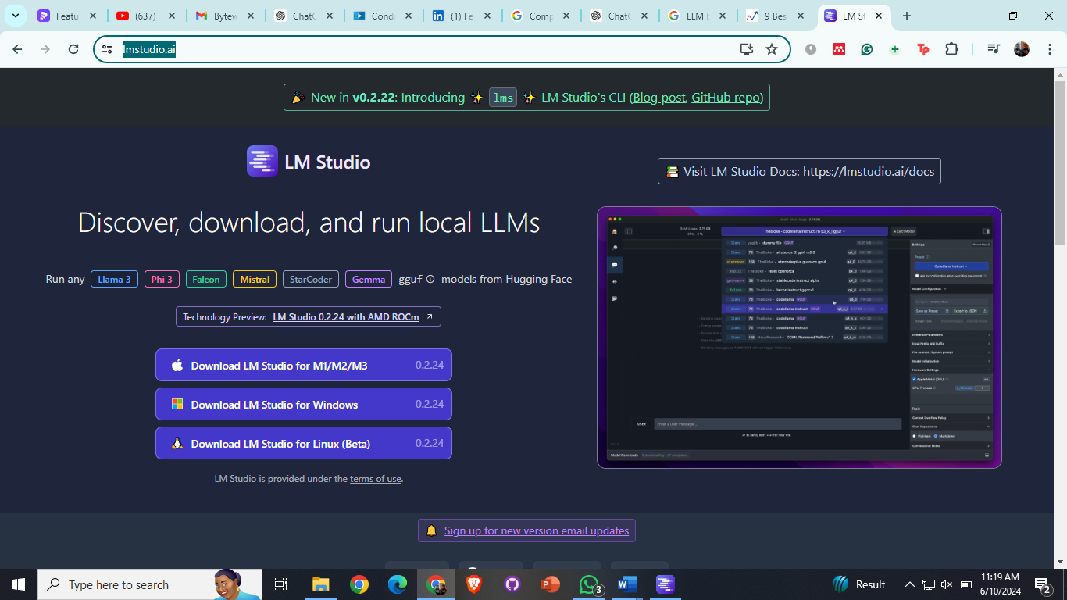

Install it and open the Desktop Application of LM studio.

Home page shown as: 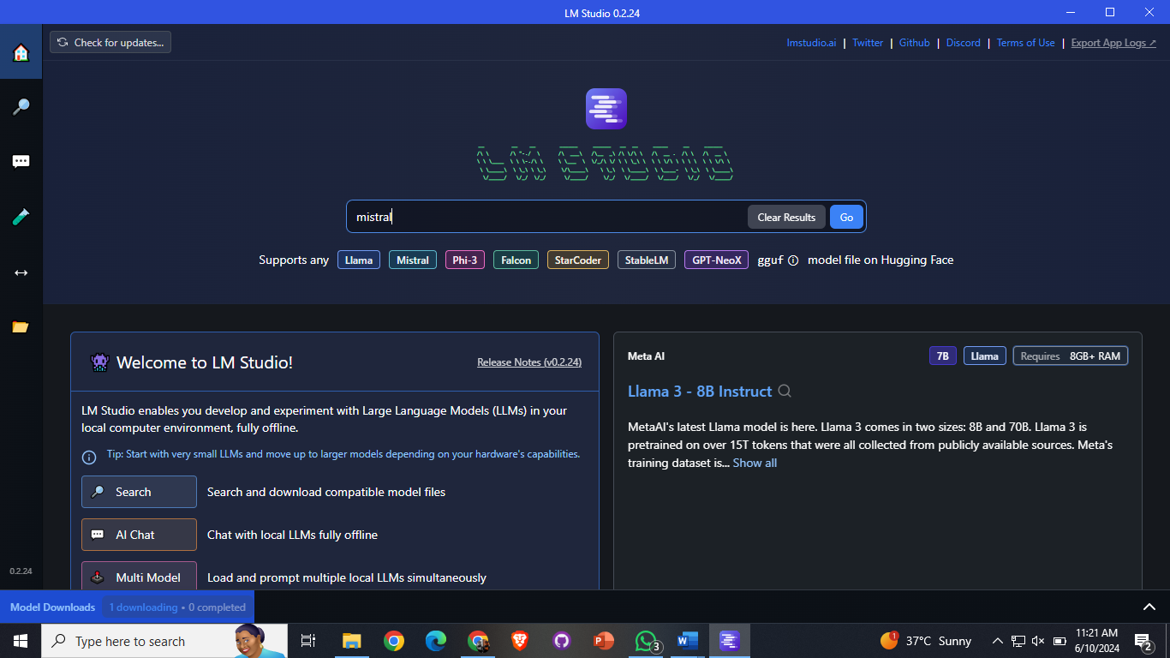

Go on search button on left side of navbar and search for any model like/ llama or misral etc as shown:   
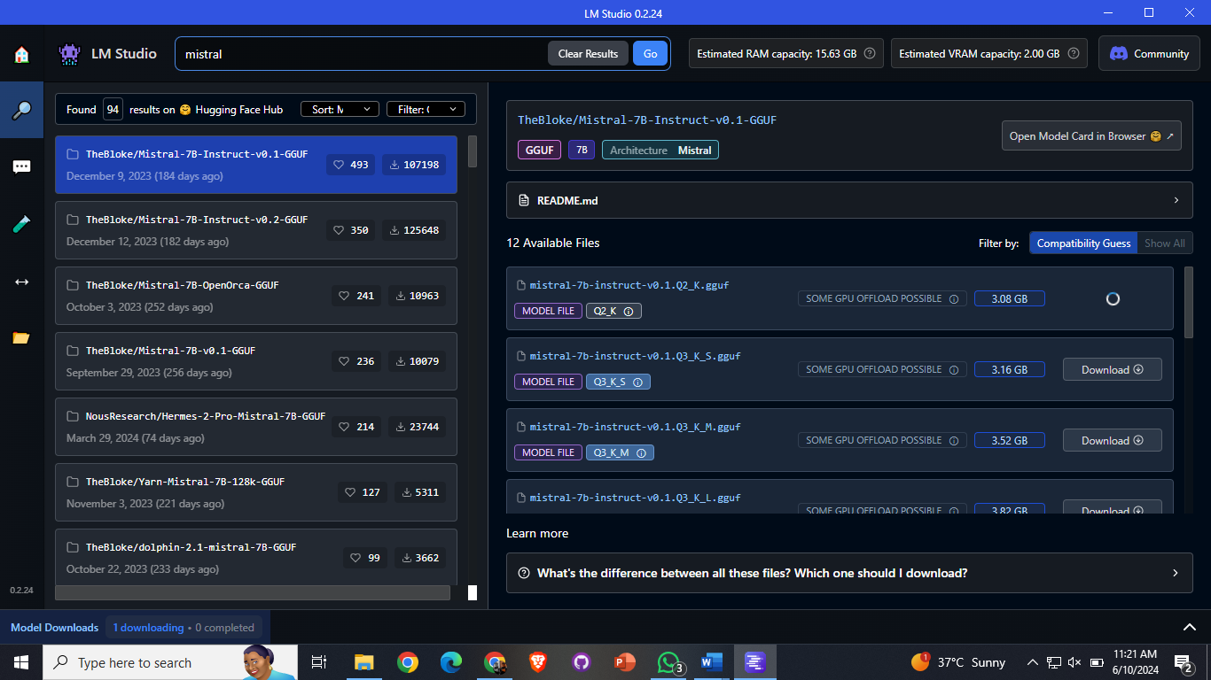

Click on the Download Button you will get details as:

